

B.Tech.-Cse(A)

Session-2016-17

“Modulation & Demodulation A.M and DSB-SC signal”

(Directed by-Analog and Digital Communication)

(Sub. Code-ECL0427)

Submitted to- Submitted by-

- Mr. Anshul Aggrawal -- Atul Anand (15028)

Bharti Parmar (15032)

Kamlesh Sharma (15048)

**“A.m & DSB-SC Signal”**

(Generation & detection)

Special Thanks:

Mr. Anshul Aggrawal, Sir

Professor, ECE-Dept.

**Table of Contents:**

**1. Objective**

**2. Introduction**

**3. Software Requirements**

**4. Team Members**

**5. Methodology**

**6. Review and Literature**

**7. Code**

**8. Output (Screen Shots)**

**9. Learning Outcome**

**10. Limitations of this project**

**11. References**

**Objective:**

The main objective of this project is to build a program for Modulation and Demodulation of A.M and DSB-SC signal.

The output of this program will give a true image of the one we get on a CRO screen. Here, we will plot curves for each of the mathematical expressions obtained for A.M and DSB-SC(A.M.) signals. This will help a peer to thoroughly understand these concepts in depth by actual visualization.

**Introduction:**

This project has made us understand the concepts and implementations of A.M signal & DSB-SC (A.M.) signal on Transmitter and Receiver side in a better way. The key idea behind this project is to build a general purpose software program to plot curves of equations. Amplitude modulation is one of the earliest radio modulation techniques. The receivers used to listen to AM-DSB-C are perhaps the simplest receivers of any radio modulation technique.

We have implemented these expressions in “MatLab graphics”. We have used some additional Matlab functions taken from Matlab official documentation for implementation.

**Team Members:**

**1. Name: Bharti Parmar**

**Roll: BETN1CS15032**

**Contribution:**

* **DSB-SC generation part**
* **Filters**
* **Documentation**

**2. Name: Kamlesh Sharma**

**Roll: BETN1CS15048**

**Contribution:**

* **Amplitude Modulation Part**
* **Error Checking**
* **Presentation (PPT)**

**3. Name: Atul Anand**

**Roll: BETN1CS15028**

**Contribution:**

* **key idea behind the project**
* **Envelope Detectors and Detection(A.M/DSB-SC)**
* **Presentation (PPT)**
* **Documentation**

**Software Requirements:**

1. MATLAB (ver_ 7.10.0 (R2010a))

2. Text Editor (Notepad)

3. OS (Windows 7 or above)

**Methodology:**

Modulation:

* A message signal is generated having frequency Fm, using:

m = cos(2*pi*Fm*t);

* A carrier signal is generated having frequency Fc, using:

c = cos(2*pi*Fc*t);

* An amplitude modulated (50%)signal is generated using:

s = c + 0.25*cos(2*pi*(Fc+Fm)*t) + 0.25*cos(2*pi*(Fc-Fm)*t);

* A DSB-SC signal is generated using a MATLAB function:

dsb_sc = ammod(m,Fc,Fs);

Demodulation:

* Coherent detection of AM signal is done using Envelope Detector:

Vc(1) = 0; % initial capacitor voltage

for i = 2:length(s)

if s(i) > Vc(i-1) % diode on (charging)

Vc(i) = s(i);

else % diode off (discharging)

Vc(i) = Vc(i-1) - 0.025*Vc(i-1);

end

end

* Non-Coherent detection of AM signal Is done using Low pass filter and special MATLAB functions:

h = fir1(100, 0.0125, 'low'); % 1 kHz cut-off frequency

foutputc = filter(h,1,Vc);

* DSB-SC demodulation using envelope detector:

Vd(1) = 0;

for i = 2:length(dsb_sc)

if dsb_sc(i) > Vd(i-1) % diode on (charging)

Vd(i) = dsb_sc(i);

else % diode off (discharging)

Vd(i) = Vd(i-1) - 0.025*Vd(i-1);

end

end

* Finally, all outputs are plotted to obtain curves.

**Review and Literature:**

## Amplitude Modulation

Amplitude modulation (AM) occurs when the amplitude of a carrier wave is modulated, to correspond to a source signal. In AM, we have an equation that looks like this:

{\displaystyle A_{signal}(t)=A(t)\sin(\omega t)} **Asignal(t)=A(t).sin(wt)**

We can also see that the phase of this wave is irrelevant, and does not change (so we don't even include it in the equation).

AM Double-Sideband (AM-DSB for short) can be broken into two different, distinct types: Carrier, and Suppressed Carrier varieties (AM-DSB-C and AM-DSB-SC, for short, respectively). This page will talk about both varieties, and will discuss the similarities and differences of each.

[](https://commons.wikimedia.org/wiki/File:Amfm2.gif)

### Characteristics:

#### Modulation Index----

Amplitude modulation requires a high frequency constant carrier and a low frequency modulation signal.

A wave carrier is not of the form **{\displaystyle e_{c}=E_{c}\cos \left({\omega _{c}t}\right)}ec=Ac.cos(wct)**

A wave modulation signal is of the form  **em=Am.cos(wmt)**

Notice that the amplitude of the high frequency carrier takes on the shape of the lower frequency modulation signal, forming what is called a modulation envelope.

[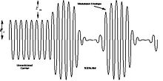](https://en.wikibooks.org/wiki/File:Am_envelope.jpg)

The modulation ASC is defined as the ratio of the modulation signal amplitude to the carrier amplitude.

**mam=Am/Ac**

{\displaystyle m_{am}={\frac {E_{m}}{E_{c}}}} where {\displaystyle 0\leq m_{am}\leq 1} **0 <=mam<= 1**

The overall signal can be described by:

**eam=(Ac+Am.cos(wmt)).cos(wct)**

More commonly, the carrier amplitude is normalized to one and the am equation is written as:

{\displaystyle e_{am}=\left({1+m_{am}\cos \left({\omega _{m}t}\right)}\right)\cos \left({\omega _{c}t}\right)} **eam=(1+mam.cos(wmt)).cos(wct)**

In most literature this expression is simply written as:

**e=(1+m.cos(wmt)).cos(wct)**

If the modulation index is zero (**mam=0** {\displaystyle m_{am}=0}) the signal is simply a constant amplitude carrier.

If the modulation index is 1 (**mam =1**), the resultant waveform has maximum or 100% amplitude modulation.

## AM-DSBSC

AM-DSB-SC is characterized by the following transmission equation: **V(t)= A[s(t)+c].cos(2.pi.Fc.t)**

Where c is a positive term representing the carrier. If the term {\displaystyle [s(t)+c]} **[s(t)+c]** is always non-negative, we can receive the AM-DSB-C signal non-coherently, using a simple envelope detector to remove the cosine term. The +c term is simply a constant DC signal and can be removed by using a blocking capacitor.

It is important to note that in AM-DSB-C systems, a large amount of power is wasted in the transmission sending a "boosted" carrier frequency. since the carrier contains no information, it is considered to be wasted energy. The advantage to this method is that it greatly simplifies the receiver design, since there is no need to generate a coherent carrier signal at the receiver. For this reason, this is the transmission method used in conventional AM radio.

AM-DSB-SC and AM-DSB-C both suffer in terms of bandwidth from the fact that they both send two identical (but reversed) frequency "lobes", or bands. These bands (the upper band and the lower band) are exactly mirror images of each other, and therefore contain identical information. Why can't we just cut one of them out, and save some bandwidth? The answer is that we can cut out one of the bands, but it isn't always a good idea. The technique of cutting out one of the sidebands is called Amplitude Modulation Single-Side-Band (AM-SSB). AM-SSB has a number of problems, but also some good aspects. A compromise between AM-SSB and the two AM-DSB methods is called Amplitude Modulation Vestigial-Side-Band (AM-VSB), which uses less bandwidth then the AM-DSB methods, but more than the AM-SSB.

**Envelope Detector**:

[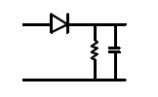](https://en.wikibooks.org/wiki/File:Envelope_detector.gif)

When trying to demodulate an AM signal, it seems like good sense that only the amplitude of the signal needs to be examined. By only examining the amplitude of the signal at any given time, we can remove the carrier signal from our considerations, and we can examine the original signal. Luckily, we have a tool in our toolbox that we can use to examine the amplitude of a signal: The Envelope Detector.

An envelope detector is simply a half wave rectifier followed by a low pass filter. In the case of commercial AM radio receivers, the detector is placed after the IF section.

An AM signal where the carrier frequency is only 10 times the envelope frequency would have considerable ripple:

[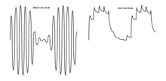](https://en.wikibooks.org/wiki/File:Exagerated_am_ripple.gif)

**Synchronous Detector**:

In a synchronous or coherent detector, the incoming AM signal is mixed with the original carrier frequency.

[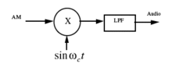](https://en.wikibooks.org/wiki/File:Synchronous_detector.gif)

If you think this looks suspiciously like a mixer, you are absolutely right! A synchronous detector is one where the difference frequency between the two inputs is zero Hz. Of in other words, the two input frequencies are the same. Let's check the math.

Recall that the AM input is mathematically defined by:

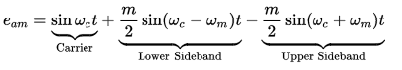

At the multiplier output, we obtain:

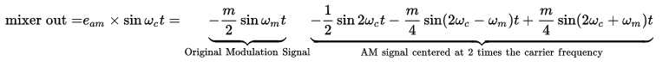

{\displaystyle {\rm {mixer}}\;{\rm {out=}}e_{am}\times \sin \omega _{c}t=\underbrace {-{\frac {m}{2}}\sin \omega _{m}t} _{{\rm {Original}}\;{\rm {Modulation}}\;{\rm {Signal}}}\underbrace {-{\frac {1}{2}}\sin 2\omega _{c}t-{\frac {m}{4}}\sin \left({2\omega _{c}-\omega _{m}}\right)t+{\frac {m}{4}}\sin \left({2\omega _{c}+\omega _{m}}\right)t} _{{\rm {AM}}\;{\rm {signal}}\;{\rm {centered}}\;{\rm {at}}\;{\rm {2}}\;{\rm {times}}\;{\rm {the}}\;{\rm {carrier}}\;{\rm {frequency}}}}

**Code (Source File):**

Mod_demod_AM.m:

%% inputs example:,,,,,,,,,,,,,,,,,,,,,,,,

%% Fc=20 , 20

%% Fs=160 , 320

%% Fm=0.4 , 0.5

% Modulation Process

Fc=input('Enter the frequency of Carrier(Khz)='); % carrier frequency of 20 kHz

Fs=input('Enter the sampling rate(per ms)='); % sampling rate of 160 samples per ms

Fm=input('Enter the frequency of modulating signal(Khz)=');

% modulating frequency of 0.4 kHz

set(0,'defaultlinelinewidth',2);

t = 0:1/Fs:10; % t of 10 seconds

c = cos(2*pi*Fc*t); % carrier signal

m = cos(2*pi*Fm*t); % modulating signal

s = c + 0.25*cos(2*pi*(Fc+Fm)*t) + 0.25*cos(2*pi*(Fc-Fm)*t);

% AM 50% mod

dsb_sc = ammod(m,Fc,Fs); % DSB-SC signal

figure; %creates a new window for demodulation

subplot(4,1,1);

plot(t, m);

title('Modulating Signal');

xlabel('time (s)');

ylabel('amplitude');

subplot(4,1,2);

plot(t, c);

title('Carrier Signal');

xlabel('time (s)');

ylabel('amplitude');

subplot(4,1,3);

plot(t, s);

title('AM Signal');

xlabel('time (s)');

ylabel('amplitude');

subplot(4,1,4);

plot(t, dsb_sc);

title('DSB-SC Signal');

xlabel('time (s)');

ylabel('amplitude');

% Non-Coherent Detection Step 1: Envelope Detection

Vc(1) = 0; % initial capacitor voltage

for i = 2:length(s)

if s(i) > Vc(i-1) % diode on (charging)

Vc(i) = s(i);

else % diode off (discharging)

Vc(i) = Vc(i-1) - 0.025*Vc(i-1);

end

end

% Non-Coherent Detection Step 2: Low Pass RC Filter

h = fir1(100, 0.0125, 'low');

% 1 kHz cut-off frequency

foutputc = filter(h,1,Vc);

Vd(1) = 0;

for i = 2:length(dsb_sc)

if dsb_sc(i) > Vd(i-1) % diode on (charging)

Vd(i) = dsb_sc(i);

else % diode off (discharging)

Vd(i) = Vd(i-1) - 0.025*Vd(i-1);

end

end

figure;

subplot(3,1,1);

plot(t, Vc);

title('Envelope detector output of AM signal');

xlabel('time (s)');

ylabel('amplitude');

grid on;

subplot(3,1,2);

plot(t, foutputc);

title('Non-coherent demodulated AM signal');

xlabel('time (s)');

ylabel('amplitude');

grid on;

subplot(3,1,3);

plot(t, Vd);

title('Envelope detector output of DSB-SC signal');

xlabel('time (s)');

ylabel('amplitude');

grid on;

**==================################===============**

**Output (Screen Shots):**

**1. Generation:**

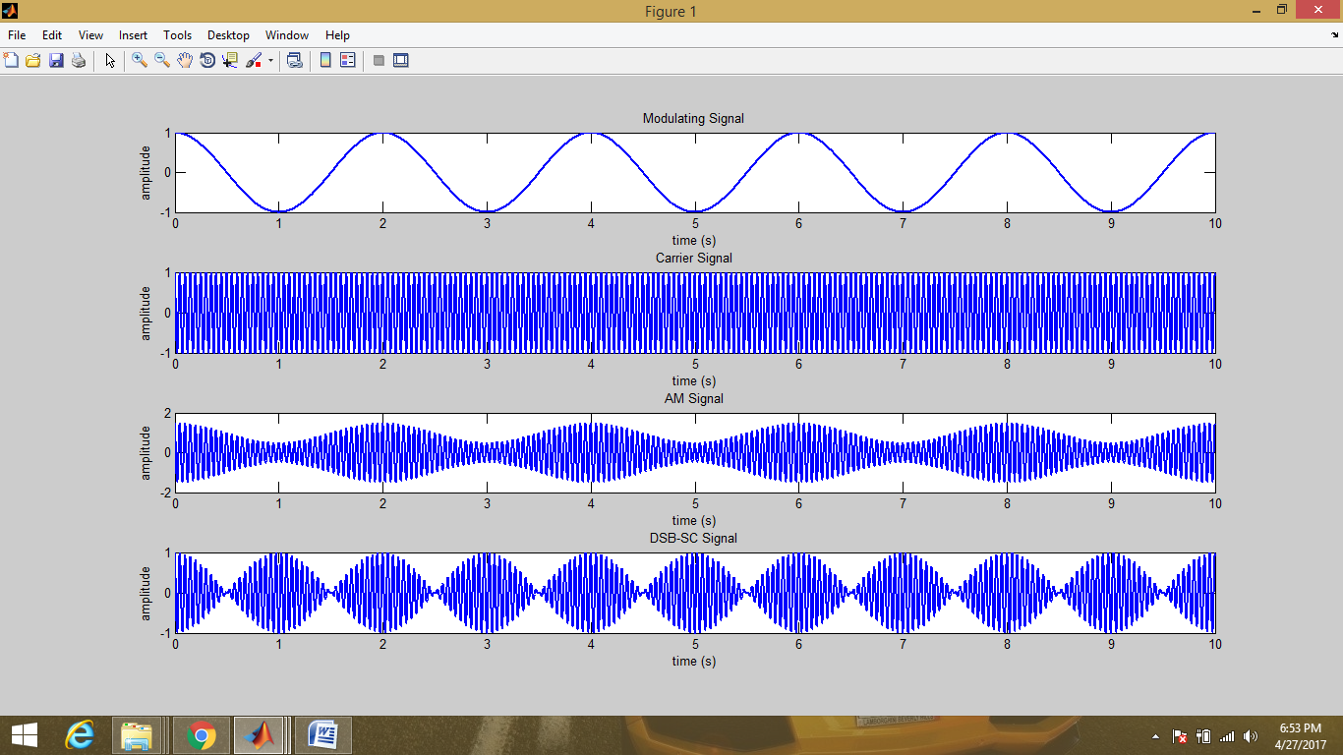**2. Detection:**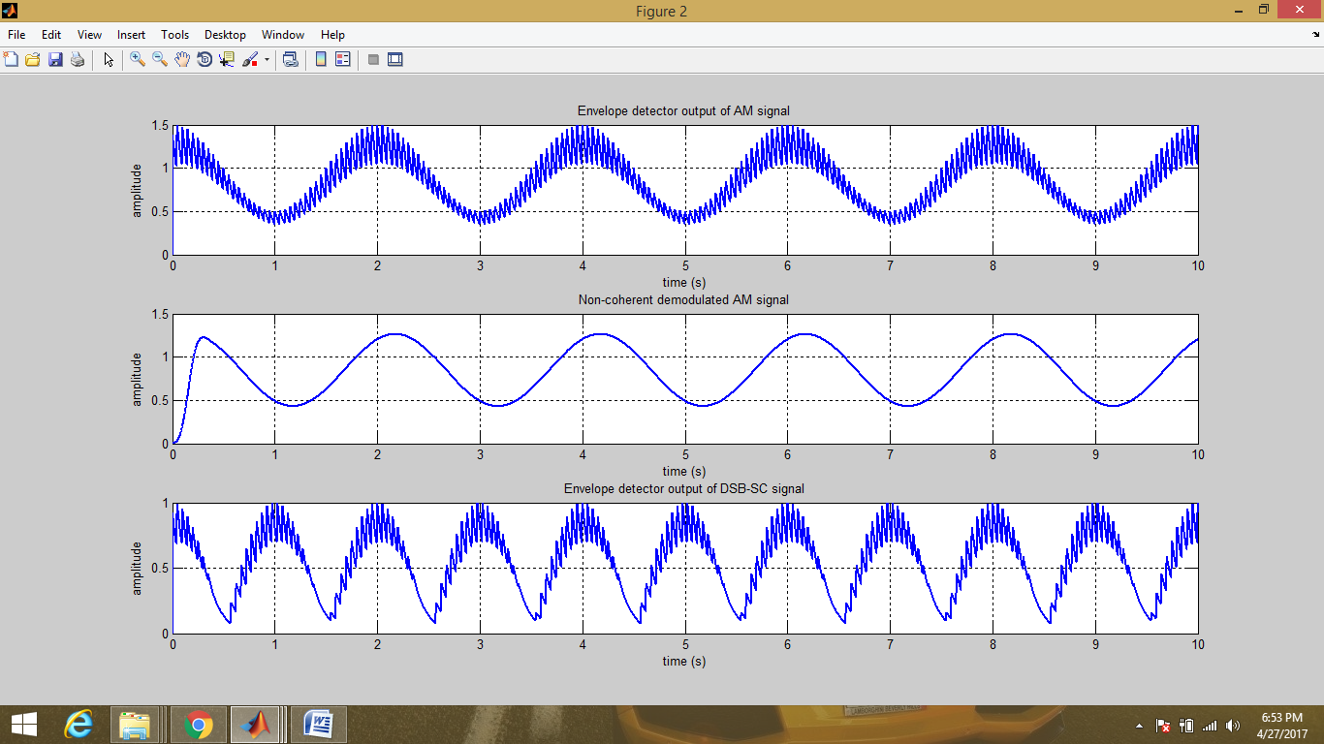

**Learning Outcome:**

Through this project based Learning methodology, we have actually got an opportunity to explore the subjects taught to us in our Academics. We have gained an experience to develop something totally functional out of raw academic stuffs.

This project can be further expanded to its next level. We can put into action for a hardware setup for these analog signals, or any application based on communication between transmitter and receiver. Additionally, we have gained the in depth concepts behind Modulation/Demodulation Techniques.

**Limitations of this project:**

* One should be cautious while feeding inputs. The vector inputs for generation and detection must be same.
* Fc >= 2*Fm.
* The Fc, Fs, Fm inputs should be in a comparable ratio.

**References:**

1. [**https://in.mathworks.com/help/signal/ref/fir1.html#bulla96**](https://in.mathworks.com/help/signal/ref/fir1.html#bulla96)
2. **https://gist.github.com/thampiman/703218**
3. **https://in.mathworks.com/help/matlab/ref/axis.html**
4. [**http://stackoverflow.com/**](http://stackoverflow.com/)
5. [**https://www.tutorialspoint.com/matlab/matlab_plotting.htm**](https://www.tutorialspoint.com/matlab/matlab_plotting.htm)
6. **https://en.wikipedia.org/wiki/Amplitude_modulation**